EDWARD D. ANESHANSLEY, MPS, PE.

224 W Shore Drive

Marblehead, MA 01945

978-578-2589

[ed.aneshansley@gmail.com](mailto:ed.aneshansley@gmail.com)

# PROFESSIONAL ACCOMPLISHMENTS

Professional Engineer PE (Environmental) MA, WI. 2006-Present

Freshwater Institutes RAS Short Course. Primary Instructor 2018-Present

WateReuse Assoc. Ag. Project of the Year Award Recipient 2017

# Aquacultural Engineering Society President/VP/BOD 2006-2014

# WORK EXPERIENCE

## Hydrotech Sustainable Foods Inc. Rolling Hills, CA. USA

**Chief Technology Officer**  2021-Present

## Lead the internal development of technology associated with clear-water, recirculation production systems for shrimp and plant-based proteins. Pair traditional recirculation process treatments with well-established wastewater treatment processes and advance the industry past the production status-quo by promoting higher densities with less water consumption. Incorporate internal proprietary water treatment technology into the production design to accelerate a zero-discharge facility design for shrimp. Optimize the construction and operational techniques to grow shrimp indoors anywhere in the world.

## McMillen Jacobs Associates Boise, ID. USA

## Senior Project Manager 2019-2022

Recirculation Aquaculture System (RAS) design specialist and project lead. I was tasked with pitching and providing technical justification to utilize RAS technology on key project where water resources were limited. I developed basis of design documents, coordinated all engineering disciplines through design development, developed written specification, construction drawing packages and cost estimates for heavy civil RAS projects. I provided site development consultation and Alternative Analysis while also coordinating permitting services and environmental assessments. I worked with key local, regional and federal agencies to properly scope projects and ensure timely progression through all stages of project development. I was further tasked with growing the RAS business opportunities in commercial aquaculture with a focus on site development, design and construction opportunities.

## Pentair Aquatic Eco-Systems Inc. Cary, NC. USA

## Engagement Manager and Engineering Advisor 2015-2019

I was the liaison between high value clients and the internal design and engineering team. I led the development of our Urban Agriculture initiative using aquaponics in climate controlled urban environments. I was the lead design architect and project manager for our innovative cold-water aquaponics flagship facility receiving the 2017 Agriculture Project of the Year award from the WateReuse Association. I led our internal focus groups associated with innovation and new product development. I would qualify and vet new high value sales and partnership opportunities worldwide. I would focus our objectives and align our resources behind core competencies and key strategic growth markets.

## Pentair Aquatic Eco-Systems Inc*.* Apopka, FL. USA

## Senior Managing Engineer 2012-2015

I managed the commercial aquaculture design team and project delivery process. I coordinated and managed an international outside sales team tasked with double digit growth in the area of commercial aquaculture. I managed contracts, engineering documents and process control. I supported the refocusing of efforts into high growth areas and shifting resources away from non-performing markets. I worked collaboratively with operations, legal, marketing, and senior advisors in market strategy development. I secured and managed the acquisition of strategic businesses to fill key gaps in product offering. I led the development of innovative new technologies and repurposed proven technologies in new markets.

## Aquatic Eco-Systems Inc. Apopka, FL. 32703

## Senior Design Engineer in Specialty Markets 2008-2012

Explored new paths to market for water-reuse technology in vocational and charter schools in the USA. I gained significant market share in that area and sustained revenue growth for all (4) years. I manage contracts and provided oversight on specialty construction projects. I managed system engineering, design and integration on large school construction projects in New York, Connecticut, and Massachusetts. I sustained high growth in my areas and positioned the business for acquisition.

## Marine Biotech Inc. Beverly, Massachusetts

**Senior Systems Engineer / Product Manager 2002-2008**

I developed a commercial scale process treatment product line for land-based recirculation aquaculture. I conducted and supported innovative research into new filtration techniques. I grew market share in other relevant markets associated with water treatment and reuse, including the Biomedical Research Industry and seafood holding and distribution. I became proficient in AutoCAD, SolidWorks and SCADA programming. I positioned the business for acquisition through innovative product development, sustained revenue growth, grit, determination and hard work.

## Cornell University Ithaca, New York

**Sea Grand Scholarship 1997 – 1999**

I managed two research labs responsible for multiple funded research projects associated with water chemistry, hydraulic engineering, biological engineering and biochemical water filtration. I supported the early development of recirculation Aquaculture through education and research. I developed and conducted personal research projects associated with my personal interests, the prerequisites of a Sea Grant Scholarship and my graduate thesis. I planned, ran and taught labs and short courses on recirculation aquaculture, engineering, chemistry and biology.

# Prince William Sound Aquaculture Corporations Cordova, Alaska

# Hatchery Field Associate 1995

I took part in the daily operation of a salmon hatchery on a remote Island in Prince William Sound, AK. I worked closely with a community of isolated individuals to complete work in an efficient and safe manner. I led the cost recovery team on “off hour” product deliveries and coordinated closely with ocean transport vessels. I created personal and team goals and objectives and drove collaboration to make process improvements.

**Atlantic Aquafarms Inc. Eastport, ME**

**Ocean Net Pen Production Associate 1994**

I managed the operation of a remote ocean-based salmon cage site in the Bay of Fundi. I captained transport vessels to and from sites, manage feeding and fish husbandry duties and supported underwater pen maintenance. My duties included maintaining fish growth rates while mitigating risk and environmental impact.

# EDUCATION

## Cornell University University of Maine, Orono, ME

Agricultural and Biological Engineering Department of Natural Resources

**Sea Grant Scholar** Concentration in Marine Resources

**Masters of Professional Studies, August 1999 Bachelor of Science, May 1995**

**AmeriCorps Program**

***In association with the Montana Conservation Corps.* Missoula, MT**

**CorpsLink Leader 1996- 1997**

I was a project leader for an “At Risk Youth” program designed to expose troubled youth to the rewards associated with community service and outdoor conservation projects. I led an eight person service crew on 10 day backcountry trail maintenance and survey expeditions in Montana and Idaho.

**PUBLICATIONS**

“**Connecticut ‘Urban Fish Farm’ leans on RAS to Produce Bronzino**”. Global Aquaculture Advocate. May 2018.

**“Standardized Evaluation and Rating of Biofilters: Manufacturer’s and User’s Perspectives**” Journal of the Aquaculture Engineering Society. 2006. Co author.

**“Design Considerations for Rack-Based Aquatic Research Facilities”** Lab Animal Magazine. Volume 34, No.1. January 2005. Author.

“**Survival and Growth of Walleye Fry as Affected by Water Recirculation, Feed Transition Age, and Stocking Density**. Journal of the World Aquaculture Society. . Vol 32, March 2001. Author.

**“Advances in Fluidized Sand Bed Biofilters”** Global Aquaculture Advocate. June 2000. Author.

**PERSONAL ACTIVITIES**

-Mountaineering

-Downhill Skiing

-Real-estate investment and renovation

-Gardening and landscape architecture

-Recreational inshore and offshore fisherman

-Skilled carpenter, plumber, electrician, and rigger.

***World Aquaculture Association***

***Aquaculture America 2018***

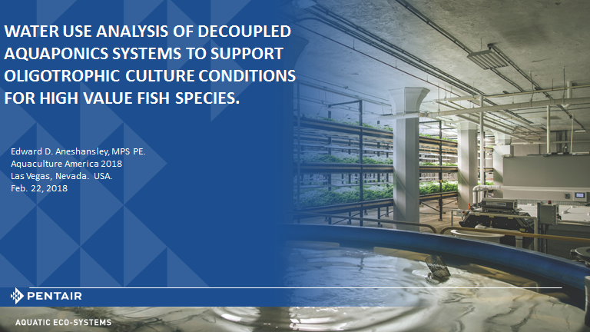

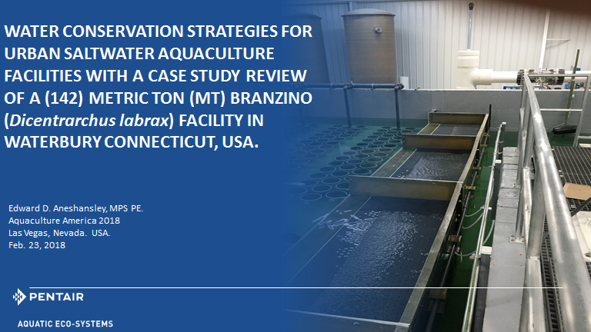

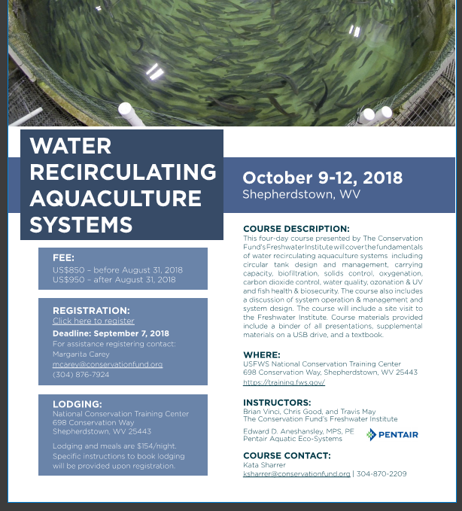

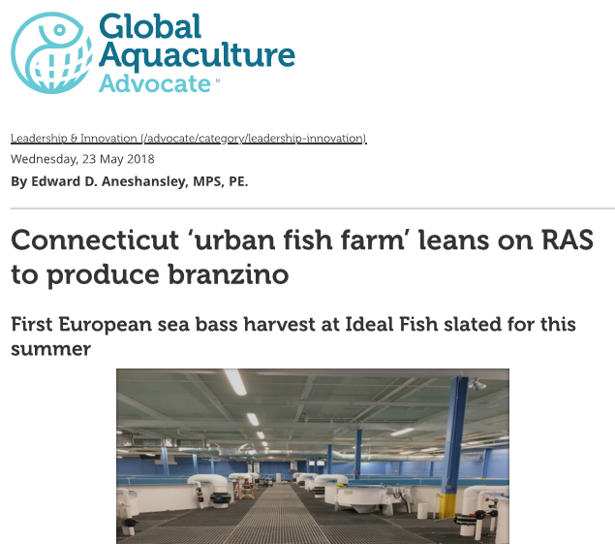***WateReuse Association***

***2017 Agriculture Project of the Year Award***

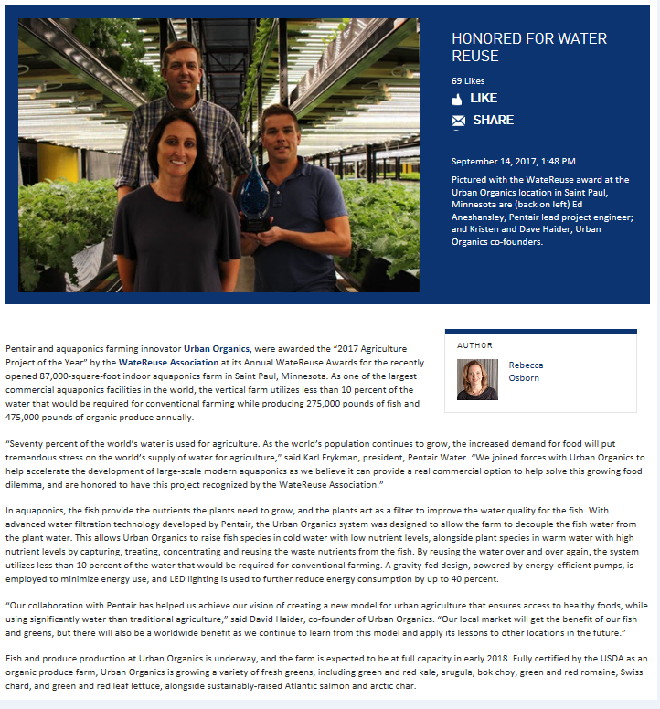

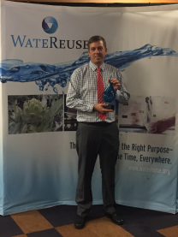

***Aquacultural Engineering Society,***

***President: 2012-2013***

**Volume 15, Issue #1**

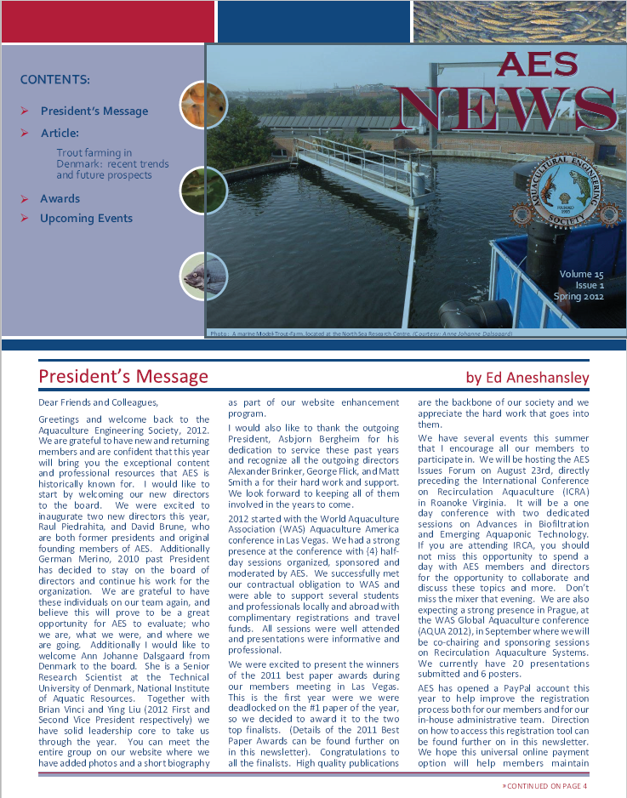

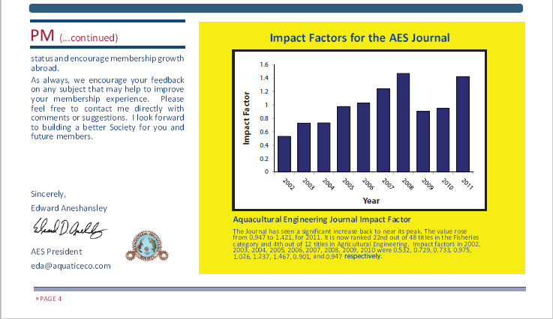

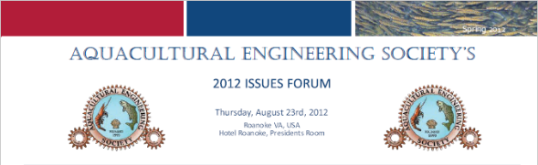

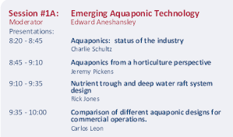

**Volume 15, Issue #2**

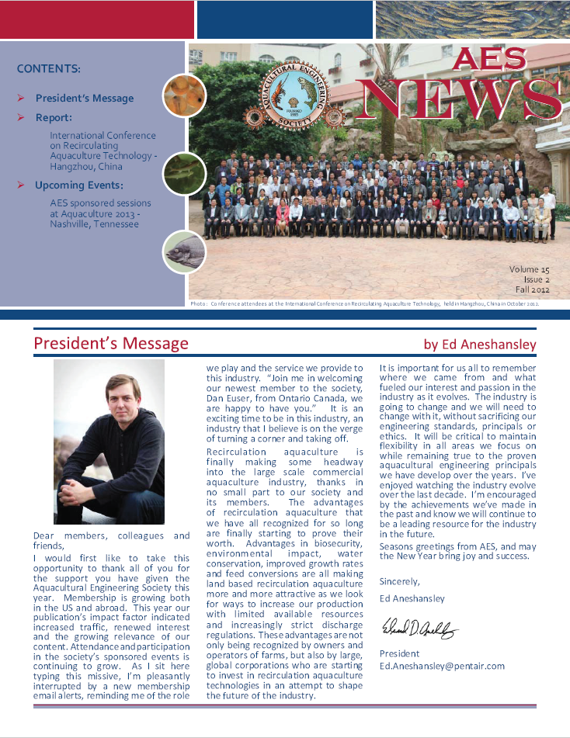

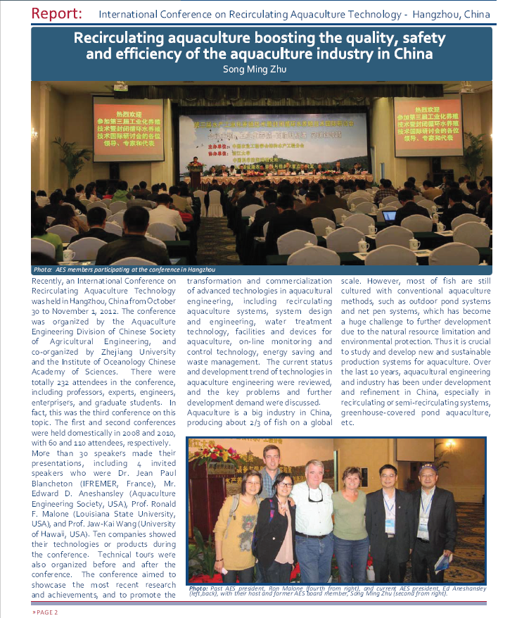

***Aquacultural Engineering Society,***

***President: 2012-2013***

**Volume 15, Issue #3**

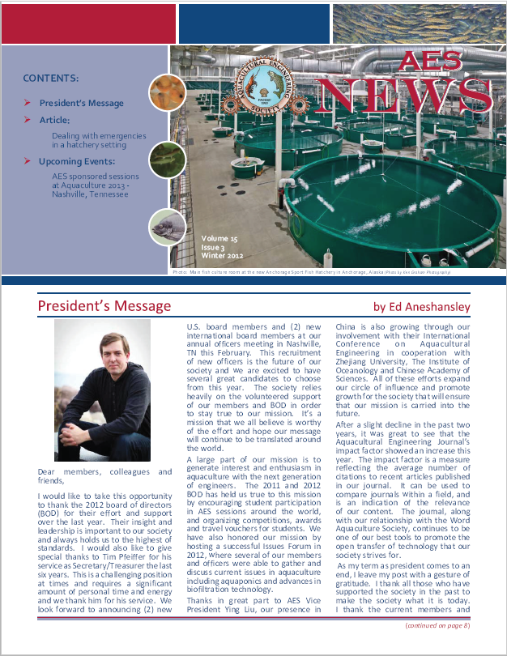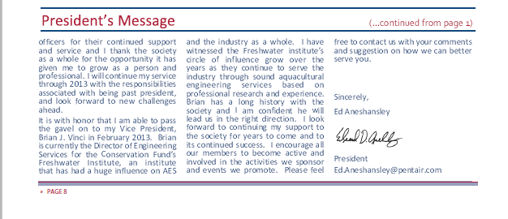

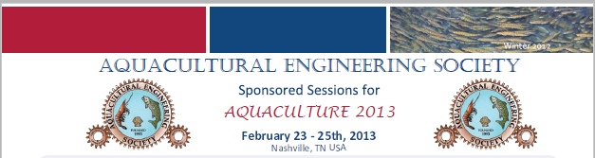

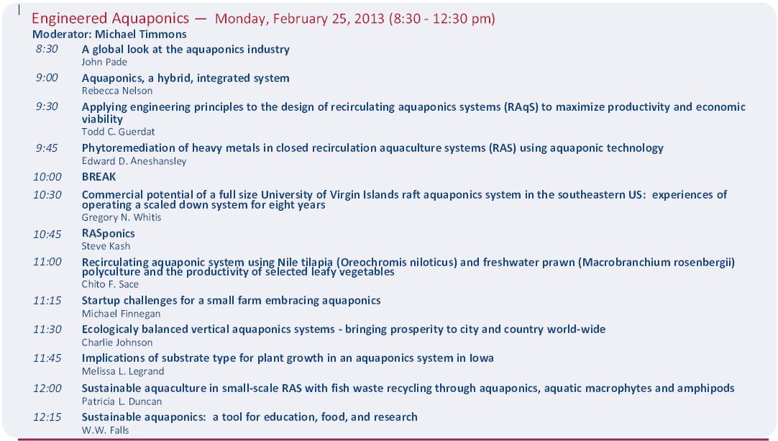

***American Society of Agricultural Engineer***

***Member Profile 2004***

